**­**

|  |  |
| --- | --- |
| **Total Marks:** | **7.5** |
| **Obtained Marks:** |  |

**FUNDAMENTALS OF**

**PROGRMMING**

**Project # 2**

**Project Title: CAR RENTAL SYSTEM**

**Submitted To: Muhammad Touqeer Ali**

**_____________________________________________________________________________________________________________________________________________________________________________________________________________________________________**

**Group Members:**

**Farooq Ahmed Khan, Azhar Kamal, Daniyal Shakeel**

**Reg. Numbers: 2012302, 2012299, 2012321**

**______________________________________________________________________________________________________________________________________________________________________________________________________________________________________**

**Title: Car Rental System**

**Introduction:**

Car Rental System is based on a concept to rent cars by using a software made for this purpose. User can select cars with a different model, and of different companies, and rent for certain days. This mini project contains limited features, but the essential one.

**Description:**  
Talking about the features of the Car Rental System, when the customer opens the program, it gets the customer to the main screen of the software. Where along with welcome message, the title of software is displayed. Then, the software asks the user to choose one from the 7 car companies of which car he wants to use. He chooses a company and then reply to the software with the car company number. If he types any digit other than the list, he will be redirected to the main menu and if he types “0”, the software gets him to the main screen too. Then after choosing a car company, the list of available cars is displayed on the screen. The model of cars, and rent per day for that car are also displayed along with that. The user will then select a car and reply with the alphabet associated to the car, or if he wants to choose another company, he can reply with d which leads him to the company selection. Anyway, when the user selects a car, he will be asked about how many days he want to rent the car for? He needs to reply in digits. When he replies with a digit, the formulas in the code calculate the rent amount for that many days and then user will be shown the total rent and for confirmation, he will be asked if he wants to proceed to payment, The user will have to reply in Yes or Not. If he says Yes, the software will display a page, where the user will input his name, NIC card number, Credit/Debit card number, CVV, and expiry date of the card. After putting all this information, he will press enter and then the software will display a Thank you statement and will confirm the payment and will tell the user to pick the car from his nearest branch. A suggestion space will be displayed at last, where the user can give any suggestion about the software or service, which will be stored in a file, by file handling.

Car Rental system is developed using C++ Programming Language and different variables, strings, arrays, functions have been used for the development of it. This mini project provides the simplest system for car rentals of a rental company.

**Procedure:**

**Code:**

|  |
| --- |
| #include <fstream>  #include <iostream>  using namespace std;  int welcome() {  string welcome ="\t\t\t\t\t\tWelcome!!\n";  cout<<welcome;  }  int main()  {  cout<<"\n\n";  jump:  welcome();  cout<<"\n";  cout<<"\t\t\t\t ----------CAR RENTAL SYSTEM---------- \n"<<endl;  cout<<"Project by: \nFarooq Ahmed Khan - 2012302\nAzhar Kamal - 2012299\nDaniyal Shakeel - 2012321\n\n\n"<<endl;  string company[7] = {"Hyundai", "Suzuki", "Daihatsu", "Honda", "Nissan", "Toyota", "Lexus"};  //variable for cars:  char car;  //variable for days:  int days;  //variable for rent:  int rent;  //variable for payment procedure:  string payment;  string name;  int nic;  int cc;  int cvv;  int cc_date;    jump1:  cout<<endl<<"Choose a Car Company from this list: \nOr Type 0 for main menu!\n"<<endl;  cout<<"1. Hyundai\n2. Suzuki\n3. Daihatsu\n4. Honda\n5. Nissan\n6. Toyota\n7. Lexus"<<endl;  cout<<"-------------------------------------"<<endl;  //input for company selection  int company_select;  cin>>company_select;  //hyundai  if (company_select == 1) {  jump0:  cout<<"-------------------------------------"<<endl;  cout<<"Please select from any of these cars:"<<endl;  cout<<"Or type d for car company selection.\n"<<endl;  cout<<"a. ACCENT\n\tModel:2017\n\tRent for 24 hours: 5000 Rs."<<endl;  cout<<"b. Santro\n\tModel:2018\n\tRent for 24 hours: 2500 Rs."<<endl;  cout<<"c. Tucson\n\tModel:2020\n\tRent for 24 hours: 7000 Rs."<<endl;  cout<<"-------------------------------------"<<endl;  cin>>car;  cout<<"-------------------------------------"<<endl;  if (car == 'a') {  cout<<"You have selected ACCENT. Please type the no. of days you want to rent this car for and we will calculate the rent:"<<endl;  cout<<"-------------------------------------"<<endl;  cin>>days;  cout<<"-------------------------------------"<<endl;  rent = days * 5000;  cout<<"According to the no. of days you provided, total rent for this car will be: "<<rent<<" Rs. \nDo you want to proceed to payment? (Yes/No)"<<endl;  cout<<"-------------------------------------"<<endl;  cin>>payment;  cout<<"-------------------------------------"<<endl;  if ( payment == "Yes") {  cout<<"Please Fill your details as well as Credit/Debit Card details for payment:"<<endl;  cout<<"Full Name: ";  cin>>name;  cout<<"NIC Number: ";  cin>>nic;  cout<<"Credit Card Number: ";  cin>>cc;  cout<<"CVV:";  cin>>cvv;  cout<<"Expiry Date: (in form of month year)";  cin>>cc_date;  cout<<"You have successfuly paid the rental amount, Please pick the car from our nearest branch!\n\n\t\t\t\t\t\t\tTHANK YOU!"<<endl;  }  if (payment == "No") {  goto jump1;  }    }  if (car == 'b') {  cout<<"You have selected Santro. Please type the no. of days you want to rent this car for and we will calculate the rent:"<<endl;  cout<<"-------------------------------------"<<endl;  cin>>days;  cout<<"-------------------------------------"<<endl;  rent = days * 2500;  cout<<"According to the no. of days you provided, total rent for this car will be: "<<rent<<" Rs. \nDo you want to proceed to payment? (Yes/No)"<<endl;  cout<<"-------------------------------------"<<endl;  cin>>payment;  cout<<"-------------------------------------"<<endl;  if ( payment == "Yes") {  cout<<"Please Fill your details as well as Credit/Debit Card details for payment:"<<endl;  cout<<"Full Name: ";  cin>>name;  cout<<"NIC Number: ";  cin>>nic;  cout<<"Credit Card Number: ";  cin>>cc;  cout<<"CVV:";  cin>>cvv;  cout<<"Expiry Date: (in form of month year)";  cin>>cc_date;  cout<<"You have successfuly paid the rental amount, Please pick the car from our nearest branch!\n\n\t\t\t\t\t\t\tTHANK YOU!"<<endl;  }  if (payment == "No") {  goto jump1;  }  }  if (car == 'c') {  cout<<"You have selected Tucson. Please type the no. of days you want to rent this car for and we will calculate the rent:"<<endl;  cout<<"-------------------------------------"<<endl;  cin>>days;  cout<<"-------------------------------------"<<endl;  rent = days * 7000;  cout<<"According to the no. of days you provided, total rent for this car will be: "<<rent<<" Rs. \nDo you want to proceed to payment? (Yes/No)"<<endl;  cout<<"-------------------------------------"<<endl;  cin>>payment;  cout<<"-------------------------------------"<<endl;  if ( payment == "Yes") {  cout<<"Please Fill your details as well as Credit/Debit Card details for payment:"<<endl;  cout<<"Full Name: ";  cin>>name;  cout<<"NIC Number: ";  cin>>nic;  cout<<"Credit Card Number: ";  cin>>cc;  cout<<"CVV:";  cin>>cvv;  cout<<"Expiry Date: (in form of month year)";  cin>>cc_date;  cout<<"You have successfuly paid the rental amount, Please pick the car from our nearest branch!\n\n\t\t\t\t\t\t\tTHANK YOU!"<<endl;  }  if (payment == "No") {  goto jump1;  }  }  if (car == 'd') {  goto jump1;  }  }  //Suzuki  if (company_select == 2) {  jump2:  cout<<"-------------------------------------"<<endl;  cout<<"Please select from any of these cars:"<<endl;  cout<<"Or type d for car company selection."<<endl;  cout<<"a. Cultus\n\tModel:2017\n\tRent for 24 hours: 2500 Rs."<<endl;  cout<<"b. Alto\n\tModel:2018\n\tRent for 24 hours: 3000 Rs."<<endl;  cout<<"c. Swift\n\tModel:2020\n\tRent for 24 hours: 4000 Rs."<<endl;  cin>>car;  if (car == 'a') {  cout<<"You have selected Suzuki Cultus. Please type the no. of days you want to rent this car for and we will calculate the rent:"<<endl;  cout<<"-------------------------------------"<<endl;  cin>>days;  cout<<"-------------------------------------"<<endl;  rent = days * 2500;  cout<<"According to the no. of days you provided, total rent for this car will be: "<<rent<<" Rs. \nDo you want to proceed to payment? (Yes/No)"<<endl;  cout<<"-------------------------------------"<<endl;  cin>>payment;  cout<<"-------------------------------------"<<endl;  if ( payment == "Yes") {  cout<<"Please Fill your details as well as Credit/Debit Card details for payment:"<<endl;  cout<<"Full Name: ";  cin>>name;  cout<<"NIC Number: ";  cin>>nic;  cout<<"Credit Card Number: ";  cin>>cc;  cout<<"CVV:";  cin>>cvv;  cout<<"Expiry Date: (in form of month year)";  cin>>cc_date;  cout<<"You have successfuly paid the rental amount, Please pick the car from our nearest branch!\n\n\t\t\t\t\t\t\tTHANK YOU!"<<endl;  }  if (payment == "No") {  goto jump2;  }  }  if (car == 'b') {  cout<<"You have selected Alto. Please type the no. of days you want to rent this car for and we will calculate the rent:"<<endl;  cout<<"-------------------------------------"<<endl;  cin>>days;  cout<<"-------------------------------------"<<endl;  rent = days * 3000;  cout<<"According to the no. of days you provided, total rent for this car will be: "<<rent<<" Rs. \nDo you want to proceed to payment? (Yes/No)"<<endl;  cout<<"-------------------------------------"<<endl;  cin>>payment;  cout<<"-------------------------------------"<<endl;  if ( payment == "Yes") {  cout<<"Please Fill your details as well as Credit/Debit Card details for payment:"<<endl;  cout<<"Full Name: ";  cin>>name;  cout<<"NIC Number: ";  cin>>nic;  cout<<"Credit Card Number: ";  cin>>cc;  cout<<"CVV:";  cin>>cvv;  cout<<"Expiry Date: (in form of month year)";  cin>>cc_date;  cout<<"You have successfuly paid the rental amount, Please pick the car from our nearest branch!\n\n\t\t\t\t\t\t\tTHANK YOU!"<<endl;  }  if (payment == "No") {  goto jump1;  }  }  if (car == 'c') {  cout<<"You have selected Swift. Please type the no. of days you want to rent this car for and we will calculate the rent:"<<endl;  cout<<"-------------------------------------"<<endl;  cin>>days;  cout<<"-------------------------------------"<<endl;  rent = days * 4000;  cout<<"According to the no. of days you provided, total rent for this car will be: "<<rent<<" Rs. \nDo you want to proceed to payment? (Yes/No)"<<endl;  cout<<"-------------------------------------"<<endl;  cin>>payment;  cout<<"-------------------------------------"<<endl;  if ( payment == "Yes") {  cout<<"Please Fill your details as well as Credit/Debit Card details for payment:"<<endl;  cout<<"Full Name: ";  cin>>name;  cout<<"NIC Number: ";  cin>>nic;  cout<<"Credit Card Number: ";  cin>>cc;  cout<<"CVV:";  cin>>cvv;  cout<<"Expiry Date: (in form of month year)";  cin>>cc_date;  cout<<"You have successfuly paid the rental amount, Please pick the car from our nearest branch!\n\n\t\t\t\t\t\t\tTHANK YOU!"<<endl;  }  if (payment == "No") {  goto jump1;  }  }  if (car == 'd') {  goto jump1;  }  }  //daihatsu  if (company_select == 3) {  jump3:  cout<<"-------------------------------------"<<endl;  cout<<"Please select from any of these cars:"<<endl;  cout<<"Or type d for car company selection."<<endl;  cout<<"a. Mira\n\tModel:2017\n\tRent for 24 hours: 2500 Rs."<<endl;  cout<<"b. Cuore\n\tModel:2012\n\tRent for 24 hours: 3000 Rs."<<endl;  cout<<"c. Move\n\tModel:2010\n\tRent for 24 hours: 2000 Rs."<<endl;  cin>>car;  if (car == 'a') {  cout<<"You have selected Mira. Please type the no. of days you want to rent this car for and we will calculate the rent:"<<endl;  cout<<"-------------------------------------"<<endl;  cin>>days;  cout<<"-------------------------------------"<<endl;  rent = days * 2500;  cout<<"According to the no. of days you provided, total rent for this car will be: "<<rent<<" Rs. \nDo you want to proceed to payment? (Yes/No)"<<endl;  cout<<"-------------------------------------"<<endl;  cin>>payment;  cout<<"-------------------------------------"<<endl;  if ( payment == "Yes") {  cout<<"Please Fill your details as well as Credit/Debit Card details for payment:"<<endl;  cout<<"Full Name: ";  cin>>name;  cout<<"NIC Number: ";  cin>>nic;  cout<<"Credit Card Number: ";  cin>>cc;  cout<<"CVV:";  cin>>cvv;  cout<<"Expiry Date: (in form of month year)";  cin>>cc_date;  cout<<"You have successfuly paid the rental amount, Please pick the car from our nearest branch!\n\n\t\t\t\t\t\t\tTHANK YOU!"<<endl;  }  if (payment == "No") {  goto jump1;  }  }  if (car == 'b') {  cout<<"You have selected Cuore. Please type the no. of days you want to rent this car for and we will calculate the rent:"<<endl;  cout<<"-------------------------------------"<<endl;  cin>>days;  cout<<"-------------------------------------"<<endl;  rent = days * 3000;  cout<<"According to the no. of days you provided, total rent for this car will be: "<<rent<<" Rs. \nDo you want to proceed to payment? (Yes/No)"<<endl;  cout<<"-------------------------------------"<<endl;  cin>>payment;  cout<<"-------------------------------------"<<endl;  if ( payment == "Yes") {  cout<<"Please Fill your details as well as Credit/Debit Card details for payment:"<<endl;  cout<<"Full Name: ";  cin>>name;  cout<<"NIC Number: ";  cin>>nic;  cout<<"Credit Card Number: ";  cin>>cc;  cout<<"CVV:";  cin>>cvv;  cout<<"Expiry Date: (in form of month year)";  cin>>cc_date;  cout<<"You have successfuly paid the rental amount, Please pick the car from our nearest branch!\n\n\t\t\t\t\t\t\tTHANK YOU!"<<endl;  }  if (payment == "No") {  goto jump1;  }  }  if (car == 'c') {  cout<<"You have selected Daihatsu Move. Please type the no. of days you want to rent this car for and we will calculate the rent:"<<endl;  cout<<"-------------------------------------"<<endl;  cin>>days;  cout<<"-------------------------------------"<<endl;  rent = days * 2000;  cout<<"According to the no. of days you provided, total rent for this car will be: "<<rent<<" Rs. \nDo you want to proceed to payment? (Yes/No)"<<endl;  cout<<"-------------------------------------"<<endl;  cin>>payment;  cout<<"-------------------------------------"<<endl;  if ( payment == "Yes") {  cout<<"Please Fill your details as well as Credit/Debit Card details for payment:"<<endl;  cout<<"Full Name: ";  cin>>name;  cout<<"NIC Number: ";  cin>>nic;  cout<<"Credit Card Number: ";  cin>>cc;  cout<<"CVV:";  cin>>cvv;  cout<<"Expiry Date: (in form of month year)";  cin>>cc_date;  cout<<"You have successfuly paid the rental amount, Please pick the car from our nearest branch!\n\n\t\t\t\t\t\t\tTHANK YOU!"<<endl;  }  if (payment == "No") {  goto jump1;  }  }  if (car == 'd') {  goto jump1;  }  }  //honda  if (company_select == 4) {  jump4:  cout<<"-------------------------------------"<<endl;  cout<<"Please select from any of these cars:"<<endl;  cout<<"Or type d for car company selection."<<endl;  cout<<"a. Civic\n\tModel:2020\n\tRent for 24 hours: 6500 Rs."<<endl;  cout<<"b. City\n\tModel:2018\n\tRent for 24 hours: 5000 Rs."<<endl;  cout<<"c. Accord\n\tModel:2020\n\tRent for 24 hours: 4000 Rs."<<endl;  cin>>car;  if (car == 'a') {  cout<<"You have selected Honda Civic. Please type the no. of days you want to rent this car for and we will calculate the rent:"<<endl;  cout<<"-------------------------------------"<<endl;  cin>>days;  cout<<"-------------------------------------"<<endl;  rent = days * 6500;  cout<<"According to the no. of days you provided, total rent for this car will be: "<<rent<<" Rs. \nDo you want to proceed to payment? (Yes/No)"<<endl;  cout<<"-------------------------------------"<<endl;  cin>>payment;  cout<<"-------------------------------------"<<endl;  if ( payment == "Yes") {  cout<<"Please Fill your details as well as Credit/Debit Card details for payment:"<<endl;  cout<<"Full Name: ";  cin>>name;  cout<<"NIC Number: ";  cin>>nic;  cout<<"Credit Card Number: ";  cin>>cc;  cout<<"CVV:";  cin>>cvv;  cout<<"Expiry Date: (in form of month year)";  cin>>cc_date;  cout<<"You have successfuly paid the rental amount, Please pick the car from our nearest branch!\n\n\t\t\t\t\t\t\tTHANK YOU!"<<endl;  }  if (payment == "No") {  goto jump1;  }  }  if (car == 'b') {  cout<<"You have selected Honda City. Please type the no. of days you want to rent this car for and we will calculate the rent:"<<endl;  cout<<"-------------------------------------"<<endl;  cin>>days;  cout<<"-------------------------------------"<<endl;  rent = days * 5000;  cout<<"According to the no. of days you provided, total rent for this car will be: "<<rent<<" Rs. \nDo you want to proceed to payment? (Yes/No)"<<endl;  cout<<"-------------------------------------"<<endl;  cin>>payment;  cout<<"-------------------------------------"<<endl;  if ( payment == "Yes") {  cout<<"Please Fill your details as well as Credit/Debit Card details for payment:"<<endl;  cout<<"Full Name: ";  cin>>name;  cout<<"NIC Number: ";  cin>>nic;  cout<<"Credit Card Number: ";  cin>>cc;  cout<<"CVV:";  cin>>cvv;  cout<<"Expiry Date: (in form of month year)";  cin>>cc_date;  cout<<"You have successfuly paid the rental amount, Please pick the car from our nearest branch!\n\n\t\t\t\t\t\t\tTHANK YOU!"<<endl;  }  if (payment == "No") {  goto jump1;  }  }  if (car == 'c') {  cout<<"You have selected Honda Accord. Please type the no. of days you want to rent this car for and we will calculate the rent:"<<endl;  cout<<"-------------------------------------"<<endl;  cin>>days;  cout<<"-------------------------------------"<<endl;  rent = days * 4000;  cout<<"According to the no. of days you provided, total rent for this car will be: "<<rent<<" Rs. \nDo you want to proceed to payment? (Yes/No)"<<endl;  cout<<"-------------------------------------"<<endl;  cin>>payment;  cout<<"-------------------------------------"<<endl;  if ( payment == "Yes") {  cout<<"Please Fill your details as well as Credit/Debit Card details for payment:"<<endl;  cout<<"Full Name: ";  cin>>name;  cout<<"NIC Number: ";  cin>>nic;  cout<<"Credit Card Number: ";  cin>>cc;  cout<<"CVV:";  cin>>cvv;  cout<<"Expiry Date: (in form of month year)";  cin>>cc_date;  cout<<"You have successfuly paid the rental amount, Please pick the car from our nearest branch!\n\n\t\t\t\t\t\t\tTHANK YOU!"<<endl;  }  if (payment == "No") {  goto jump1;  }  }  if (car == 'd') {  goto jump1;  }  }  //Nissan  if (company_select == 5) {  jump5:  cout<<"-------------------------------------"<<endl;  cout<<"Please select from any of these cars:"<<endl;  cout<<"Or type d for car company selection."<<endl;  cout<<"a. GT-R\n\tModel:2017\n\tRent for 24 hours: 10000 Rs."<<endl;  cout<<"b. Juke\n\tModel:2020\n\tRent for 24 hours: 5000 Rs."<<endl;  cout<<"c. Wingroad\n\tModel:2016\n\tRent for 24 hours: 5000 Rs."<<endl;  cin>>car;  if (car == 'a') {  cout<<"You have selected Nissan GT-R. Please type the no. of days you want to rent this car for and we will calculate the rent:"<<endl;  cout<<"-------------------------------------"<<endl;  cin>>days;  cout<<"-------------------------------------"<<endl;  rent = days * 10000;  cout<<"According to the no. of days you provided, total rent for this car will be: "<<rent<<" Rs. \nDo you want to proceed to payment? (Yes/No)"<<endl;  cout<<"-------------------------------------"<<endl;  cin>>payment;  cout<<"-------------------------------------"<<endl;  if ( payment == "Yes") {  cout<<"Please Fill your details as well as Credit/Debit Card details for payment:"<<endl;  cout<<"Full Name: ";  cin>>name;  cout<<"NIC Number: ";  cin>>nic;  cout<<"Credit Card Number: ";  cin>>cc;  cout<<"CVV:";  cin>>cvv;  cout<<"Expiry Date: (in form of month year)";  cin>>cc_date;  cout<<"You have successfuly paid the rental amount, Please pick the car from our nearest branch!\n\n\t\t\t\t\t\t\tTHANK YOU!"<<endl;  }  if (payment == "No") {  goto jump1;  }  }  if (car == 'b') {  cout<<"You have selected Nissan Juke. Please type the no. of days you want to rent this car for and we will calculate the rent:"<<endl;  cout<<"-------------------------------------"<<endl;  cin>>days;  cout<<"-------------------------------------"<<endl;  rent = days * 5000;  cout<<"According to the no. of days you provided, total rent for this car will be: "<<rent<<" Rs. \nDo you want to proceed to payment? (Yes/No)"<<endl;  cout<<"-------------------------------------"<<endl;  cin>>payment;  cout<<"-------------------------------------"<<endl;  if ( payment == "Yes") {  cout<<"Please Fill your details as well as Credit/Debit Card details for payment:"<<endl;  cout<<"Full Name: ";  cin>>name;  cout<<"NIC Number: ";  cin>>nic;  cout<<"Credit Card Number: ";  cin>>cc;  cout<<"CVV:";  cin>>cvv;  cout<<"Expiry Date: (in form of month year)";  cin>>cc_date;  cout<<"You have successfuly paid the rental amount, Please pick the car from our nearest branch!\n\n\t\t\t\t\t\t\tTHANK YOU!"<<endl;  }  if (payment == "No") {  goto jump1;  }  }  if (car == 'c') {  cout<<"You have selected Nissan Wingroad. Please type the no. of days you want to rent this car for and we will calculate the rent:"<<endl;  cout<<"-------------------------------------"<<endl;  cin>>days;  cout<<"-------------------------------------"<<endl;  rent = days * 5000;  cout<<"According to the no. of days you provided, total rent for this car will be: "<<rent<<" Rs. \nDo you want to proceed to payment? (Yes/No)"<<endl;  cout<<"-------------------------------------"<<endl;  cin>>payment;  cout<<"-------------------------------------"<<endl;  if ( payment == "Yes") {  cout<<"Please Fill your details as well as Credit/Debit Card details for payment:"<<endl;  cout<<"Full Name: ";  cin>>name;  cout<<"NIC Number: ";  cin>>nic;  cout<<"Credit Card Number: ";  cin>>cc;  cout<<"CVV:";  cin>>cvv;  cout<<"Expiry Date: (in form of month year)";  cin>>cc_date;  cout<<"You have successfuly paid the rental amount, Please pick the car from our nearest branch!\n\n\t\t\t\t\t\t\tTHANK YOU!"<<endl;  }  if (payment == "No") {  goto jump1;  }  }  if (car == 'd') {  goto jump1;  }  }  //Toyota  if (company_select == 6) {  jump6:  cout<<"-------------------------------------"<<endl;  cout<<"Please select from any of these cars:"<<endl;  cout<<"Or type d for car company selection."<<endl;  cout<<"a. Corolla\n\tModel:2017\n\tRent for 24 hours: 4500 Rs."<<endl;  cout<<"b. Yaris\n\tModel:2018\n\tRent for 24 hours: 4000 Rs."<<endl;  cout<<"c. Prius\n\tModel:2020\n\tRent for 24 hours: 4000 Rs."<<endl;  cin>>car;  if (car == 'a') {  cout<<"You have selected Toyota Corolla. Please type the no. of days you want to rent this car for and we will calculate the rent:"<<endl;  cout<<"-------------------------------------"<<endl;  cin>>days;  cout<<"-------------------------------------"<<endl;  rent = days * 4500;  cout<<"According to the no. of days you provided, total rent for this car will be: "<<rent<<" Rs. \nDo you want to proceed to payment? (Yes/No)"<<endl;  cout<<"-------------------------------------"<<endl;  cin>>payment;  cout<<"-------------------------------------"<<endl;  if ( payment == "Yes") {  cout<<"Please Fill your details as well as Credit/Debit Card details for payment:"<<endl;  cout<<"Full Name: ";  cin>>name;  cout<<"NIC Number: ";  cin>>nic;  cout<<"Credit Card Number: ";  cin>>cc;  cout<<"CVV:";  cin>>cvv;  cout<<"Expiry Date: (in form of month year)";  cin>>cc_date;  cout<<"You have successfuly paid the rental amount, Please pick the car from our nearest branch!\n\n\t\t\t\t\t\t\tTHANK YOU!"<<endl;  }  if (payment == "No") {  goto jump1;  }  }  if (car == 'b') {    cout<<"You have selected Toyota Yaris. Please type the no. of days you want to rent this car for and we will calculate the rent:"<<endl;  cout<<"-------------------------------------"<<endl;  cin>>days;  cout<<"-------------------------------------"<<endl;  rent = days * 4000;  cout<<"According to the no. of days you provided, total rent for this car will be: "<<rent<<" Rs. \nDo you want to proceed to payment? (Yes/No)"<<endl;  cout<<"-------------------------------------"<<endl;  cin>>payment;  cout<<"-------------------------------------"<<endl;  if ( payment == "Yes") {  cout<<"Please Fill your details as well as Credit/Debit Card details for payment:"<<endl;  cout<<"Full Name: ";  cin>>name;  cout<<"NIC Number: ";  cin>>nic;  cout<<"Credit Card Number: ";  cin>>cc;  cout<<"CVV:";  cin>>cvv;  cout<<"Expiry Date: (in form of month year)";  cin>>cc_date;  cout<<"You have successfuly paid the rental amount, Please pick the car from our nearest branch!\n\n\t\t\t\t\t\t\tTHANK YOU!"<<endl;  }  if (payment == "No") {  goto jump1;  }  }  if (car == 'c') {  cout<<"You have selected Prius. Please type the no. of days you want to rent this car for and we will calculate the rent:"<<endl;  cout<<"-------------------------------------"<<endl;  cin>>days;  cout<<"-------------------------------------"<<endl;  rent = days * 4000;  cout<<"According to the no. of days you provided, total rent for this car will be: "<<rent<<" Rs. \nDo you want to proceed to payment? (Yes/No)"<<endl;  cout<<"-------------------------------------"<<endl;  cin>>payment;  cout<<"-------------------------------------"<<endl;  if ( payment == "Yes") {  cout<<"Please Fill your details as well as Credit/Debit Card details for payment:"<<endl;  cout<<"Full Name: ";  cin>>name;  cout<<"NIC Number: ";  cin>>nic;  cout<<"Credit Card Number: ";  cin>>cc;  cout<<"CVV:";  cin>>cvv;  cout<<"Expiry Date: (in form of month year)";  cin>>cc_date;  cout<<"You have successfuly paid the rental amount, Please pick the car from our nearest branch!\n\n\t\t\t\t\t\t\tTHANK YOU!"<<endl;  }  if (payment == "No") {  goto jump1;  }  }  if (car == 'd') {  goto jump1;  }  }  //Lexus  if (company_select == 7) {  jump7:  cout<<"-------------------------------------"<<endl;  cout<<"Please select from any of these cars:"<<endl;  cout<<"Or type d for car company selection."<<endl;  cout<<"a. LS 400\n\tModel:2017\n\tRent for 24 hours: 10000 Rs."<<endl;  cout<<"b. CT 200h\n\tModel:2016\n\tRent for 24 hours: 8000 Rs."<<endl;  cout<<"c. RX 450h\n\tModel:2014\n\tRent for 24 hours: 75000 Rs."<<endl;  cin>>car;  if (car == 'a') {  cout<<"You have selected LS 400. Please type the no. of days you want to rent this car for and we will calculate the rent:"<<endl;  cout<<"-------------------------------------"<<endl;  cin>>days;  cout<<"-------------------------------------"<<endl;  rent = days * 10000;  cout<<"According to the no. of days you provided, total rent for this car will be: "<<rent<<" Rs. \nDo you want to proceed to payment? (Yes/No)"<<endl;  cout<<"-------------------------------------"<<endl;  cin>>payment;  cout<<"-------------------------------------"<<endl;  if ( payment == "Yes") {  cout<<"Please Fill your details as well as Credit/Debit Card details for payment:"<<endl;  cout<<"Full Name: ";  cin>>name;  cout<<"NIC Number: ";  cin>>nic;  cout<<"Credit Card Number: ";  cin>>cc;  cout<<"CVV:";  cin>>cvv;  cout<<"Expiry Date: (in form of month year)";  cin>>cc_date;  cout<<"You have successfuly paid the rental amount, Please pick the car from our nearest branch!\n\n\t\t\t\t\t\t\tTHANK YOU!"<<endl;  }  if (payment == "No") {  goto jump1;  }  }  if (car == 'b') {  cout<<"You have selected CT 200h. Please type the no. of days you want to rent this car for and we will calculate the rent:"<<endl;  cout<<"-------------------------------------"<<endl;  cin>>days;  cout<<"-------------------------------------"<<endl;  rent = days * 8500;  cout<<"According to the no. of days you provided, total rent for this car will be: "<<rent<<" Rs. \nDo you want to proceed to payment? (Yes/No)"<<endl;  cout<<"-------------------------------------"<<endl;  cin>>payment;  cout<<"-------------------------------------"<<endl;  if ( payment == "Yes") {  cout<<"Please Fill your details as well as Credit/Debit Card details for payment:"<<endl;  cout<<"Full Name: ";  cin>>name;  cout<<"NIC Number: ";  cin>>nic;  cout<<"Credit Card Number: ";  cin>>cc;  cout<<"CVV:";  cin>>cvv;  cout<<"Expiry Date: (in form of month year)";  cin>>cc_date;  cout<<"You have successfuly paid the rental amount, Please pick the car from our nearest branch!\n\n\t\t\t\t\t\t\tTHANK YOU!"<<endl;  }  if (payment == "No") {  goto jump1;  }  }  if (car == 'c') {  cout<<"You have selected RTX 450h. Please type the no. of days you want to rent this car for and we will calculate the rent:"<<endl;  cout<<"-------------------------------------"<<endl;  cin>>days;  cout<<"-------------------------------------"<<endl;  rent = days * 8000;  cout<<"According to the no. of days you provided, total rent for this car will be: "<<rent<<" Rs. \nDo you want to proceed to payment? (Yes/No)"<<endl;  cout<<"-------------------------------------"<<endl;  cin>>payment;  cout<<"-------------------------------------"<<endl;  if ( payment == "Yes") {  cout<<"Please Fill your details as well as Credit/Debit Card details for payment:"<<endl;  cout<<"Full Name: ";  cin>>name;  cout<<"NIC Number: ";  cin>>nic;  cout<<"Credit Card Number: ";  cin>>cc;  cout<<"CVV:";  cin>>cvv;  cout<<"Expiry Date: (in form of month year)";  cin>>cc_date;  cout<<"You have successfuly paid the rental amount, Please pick the car from our nearest branch!\n\n\t\t\t\t\t\t\tTHANK YOU!"<<endl;  }  if (payment == "No") {  goto jump1;  }  }  if (car == 'd') {  goto jump1;  }  }  if (company_select == 0) {  goto jump;  }  if (company_select <1 || company_select >7) {  cout<<"Please select a company from the list!\n";  }  char suggestion[300];  ofstream outfile;  outfile.open("afile.dat");  cout<<"Suggestions (if any) ";  cin.getline(suggestion, 300);    outfile<<suggestion<<endl;    cout<<": ";  cin>>suggestion;  cin.ignore();    outfile<<suggestion<<endl;  outfile.close();    return 0;  } |

**Screenshots:**

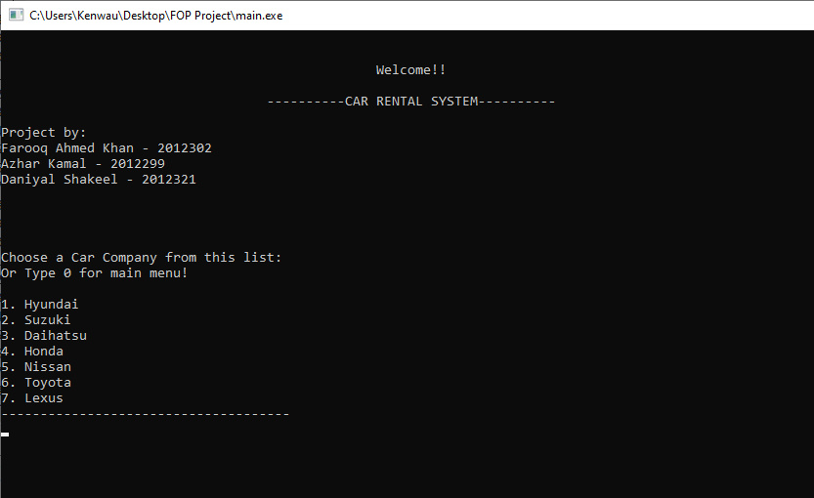  
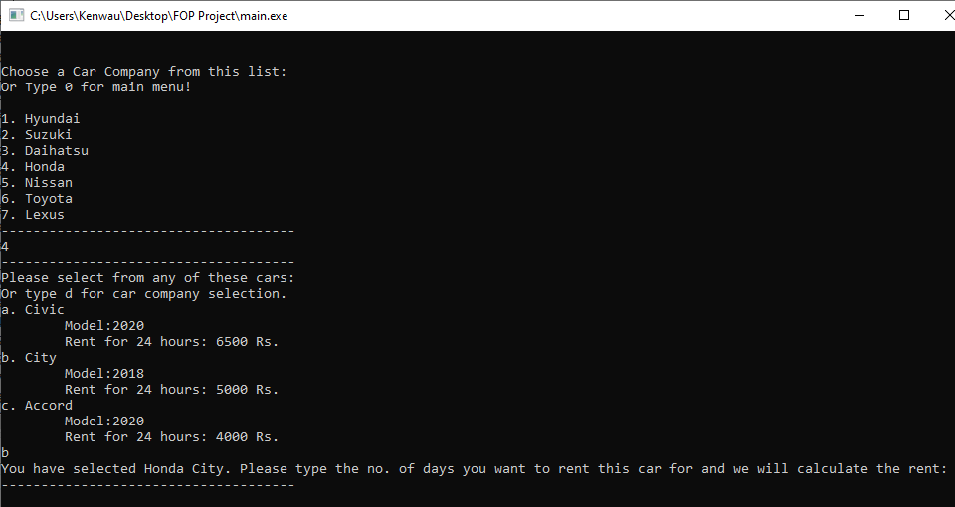

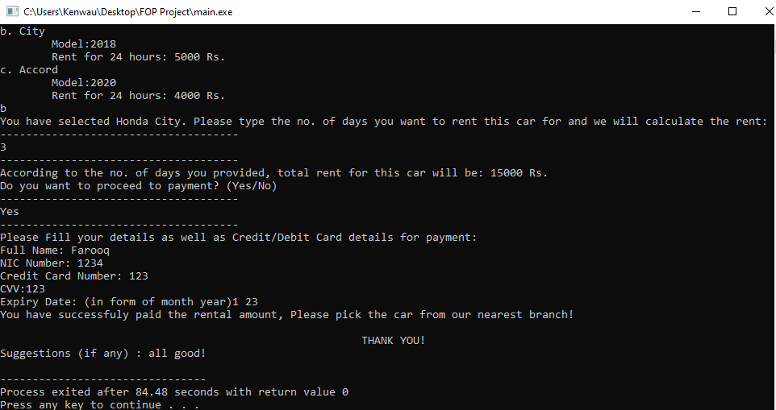

**PROBLEMS:**

Main Problem was its complex structure, because of which we were having difficulties in tracing problems which are not considered as errors by were against our design.   
Moreover, there was a problem with if-else statement, else statement was not working or if working, it was not behaving as normal. Thus, when we were unable to resolve the else issue, we used nested-if and ladder-if statements.  
While making arrays, we were having some problems about sorting data but it got resolved.

**Conclusions:**

This program is based on simple and easy C++ structure. It can be made more advanced to use it for real. This project added much more to our C++ skills and made our base stronger, and cleared many things about it.